1.

#include <iostream>

using namespace std;

int main()

{

float weight,height;

cout<<"input weight:";

cin>>weight;

cout<<"input height(m):";

cin>>height;

float BMI=weight/(height\*height);

if (BMI<18.5)

cout<<"體重過輕";

else if (BMI>=18.5&&BMI<24)

cout<<"體重標準";

else if (BMI>=24)

cout<<"體重過重";

return 0;

}

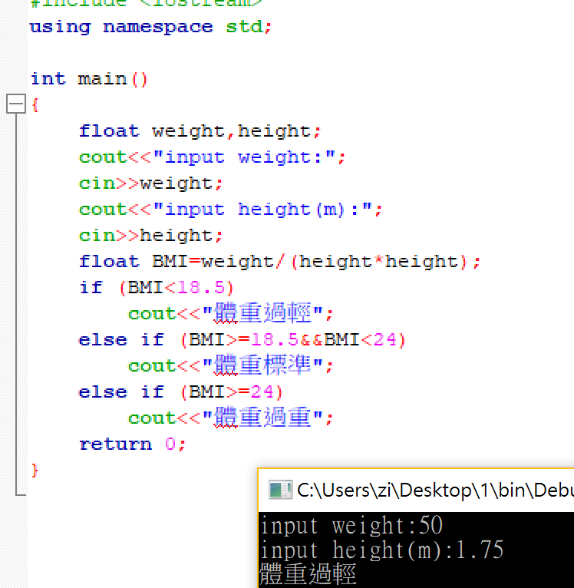

2.

#include <iostream>

using namespace std;

int main()

{

int month;

cin>>month;

if (month==12||month==1||month==2)

cout<<"Winter";

else if (month==3||month==4||month==5)

cout<<"Spring";

else if (month==6||month==7||month==8)

cout<<"Summer";

else if (month==9||month==10||month==11)

cout<<"Autumn";

else

cout<<"Error";

return 0;

}

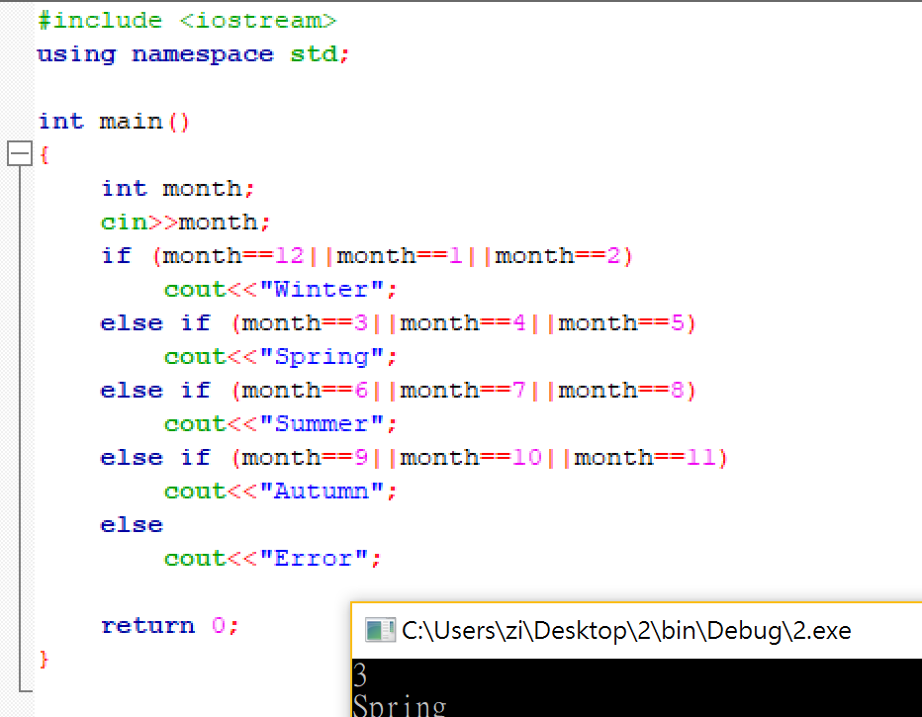

3.

#include <iostream>

using namespace std;

int main()

{

int num;

cin>>num;

int i,j,k;

for (i=1; i<=num; i++)

{

for(j=0; j<num-i; j++)

{

cout<<' ';

}

for (k=0; k<i; k++)

{

cout<<i;

}

cout<<endl;

}

for (i=num-1; i>=0; i--)

{

for(j=1; j<=num-i; j++)

{

cout<<' ';

}

for (k=i; k>0; k--)

{

cout<<i;

}

cout<<endl;

}

return 0;

}

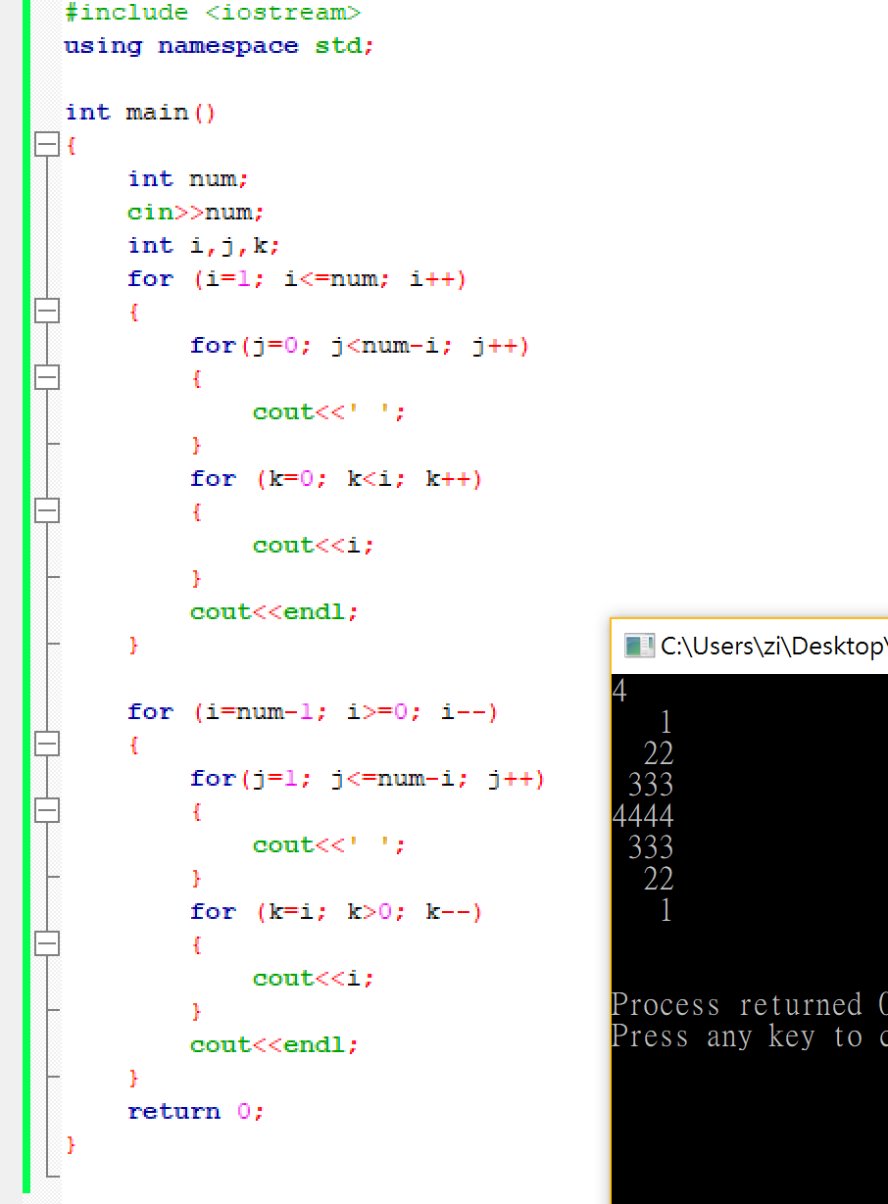

4.

#include <iostream>

using namespace std;

int main()

{

for (int i=1; i<=16;i++)

{

for (int j=1; j<=16; j++)

{

cout<<hex<<i<<"x"<<j<<"="<<i\*j<<' ';

}

cout<<endl;

}

return 0;

}

